1- How many pods exist on the system?



2- How many Nodes exist on the system?



3- Create a new pod with the nginx image.

Image name: nginx



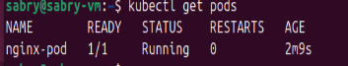

4- Which nodes are these pods placed on?

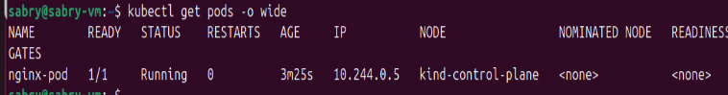

Kind-control-plane

5- Create pod from the below yaml using kubectl apply command

apiVersion: v1

kind: Pod

metadata:

name: webapp

namespace: default

spec:

containers:

- image: nginx

imagePullPolicy: Always

name: nginx

- image: agentx

imagePullPolicy: Always

name: agentx

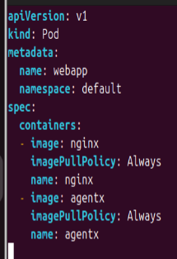



6- How many containers are part of the pod webapp

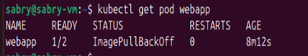

TWO Pods

7- What images are used in the new webapp pod?

**Command : kubectl describe pod webapp**

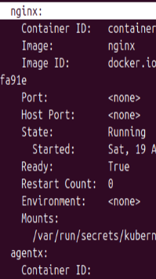

-nginx

-agentx

8- What is the state of the container agentx in the pod webapp

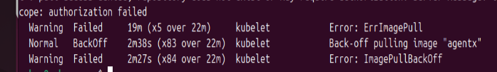

Error:ImagepullBackoff

9- Why do you think the container agentx in pod webapp is in error?

Kubernetes is unable to pull the agentx

Because the image agentx doesn’t exist or maybe it’s private image

10- Delete the webapp Pod.



11- Create a new pod with the name redis and with the image redis123.

* Name: redis
* Image Name: redis123

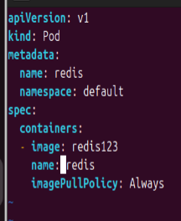

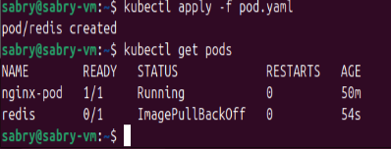

12- Now change the image on this pod to redis.

Once done, the pod should be in a running state.

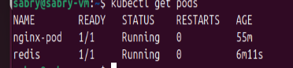

13- Create a pod called my-pod of image nginx:alpine

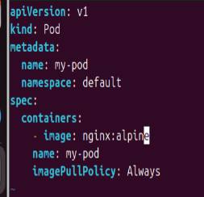

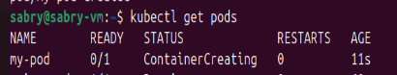

14- Delete the pod called my-pod

